**POKEDEX USING POKEAPI**

Johnrei S. Moog

BSIT - 312

**FINAL OUTPUT:**



**PROCESS**

**HTML**

I layout the basic HTML Structure for the pokedex app. I also imported to my workspace the background image from that I will use. I used the .pagination div with a “next” and “previous” buttons for navigating through different pages of the pokedex.

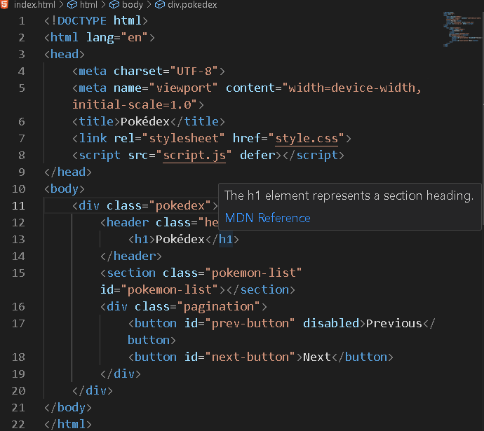

**CSS**

I center all of the content and add the background image to give it some new look. For the font I used the one that almost look like a iOS/MacOs font that I get from chatgpt and google font.

For the pokemon lists I used grid layout and display the cards in row of three for minimalize look. For the card styling I used 10px for the padding for defined space, 8px for border radius for slightly round edges , white background color for the cards to compliment the background image, for the pokemon images I used 100px for height and width to balance it’s size. For the pagination I center the “next” and “previous button” for a clean look.

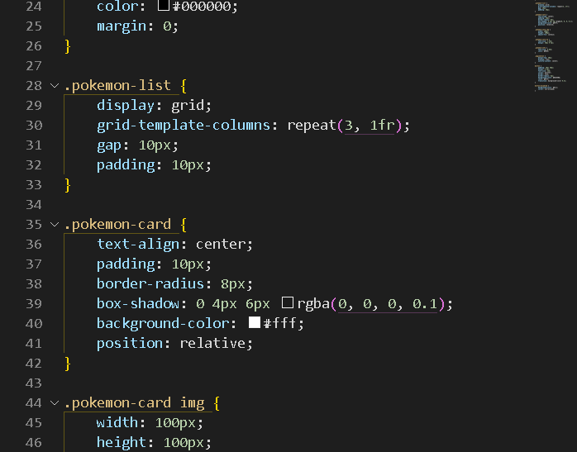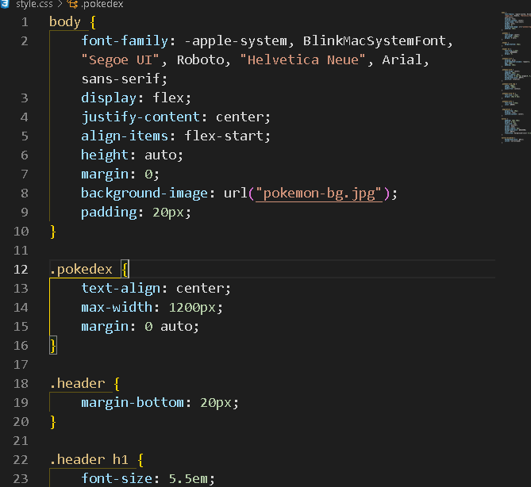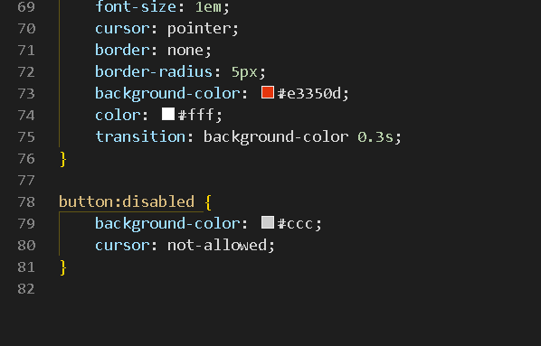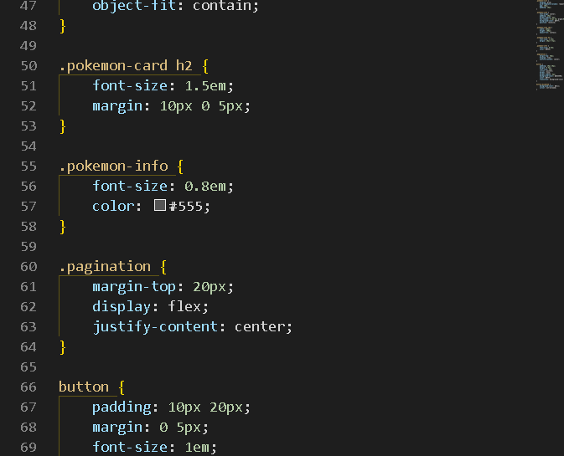

**JAVASCRIPT**

The pokemon-list, prevlist, nextlist elements are selected from the html file to give functionality to the buttons. I also set the pokemon list to 9 pokemons per page. The total pokemon elements will display the number of pokemons from the API. Calculates the offset for the page based on the currentpage and pokemonperpage that is set to 9. Then it fetches a list of pokemon and urls from the PokeAPI. After that it calls the displaypokemons to show the pokemons and update the pagination buttons. For the displaypokemons element it clears then loops to each pokemon and fetch its details using fetchpokemondetails.

It fetches the pokemon details from the api and display it to the pages using createpokemoncard. It builds a card for each pokemon with details such as ID, type, height and weight and it adds the pokemon along with its details to #pokemon-list section. For the pagination if it is in the first page it disable the previous button and disable the next button if it is in the last page.

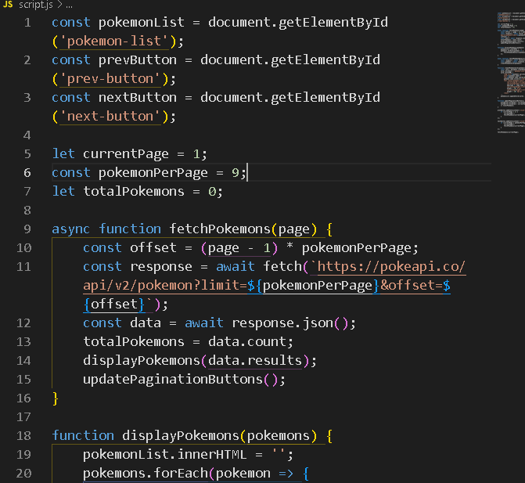The event listener updates the currentpage and fetch a new set of pokemons based on the page for the last line of code the fetchPokemons is for the first page in the startup.

